Cecily Wang/Munoz-Pastrana

EE309 Research Paper Spring 2024

Professor Cleveland Cutler

28 April 2024

Word Count: 4211

**Nuclear Energy:**

**Fighting for the Sustainable Well-being of Humans and the Environment**

**Introduction**

As the world faces the challenges of climate change, energy insecurity, and shifting economic powers, the demand for a transition from traditional energy sources like that of fossil fuels to more sustainable alternatives is experiencing a greater influx of investment and knowledge as we go further into the battle between the natural environment and our own human interest and attempt to create a long term balance between the two. This environmental reality has driven a common goal for cleaner, more sustainable energy solutions that will enable sustainable living for generations to come. One of the most controversial clean energy services that shows promise for our global collective sustainability goal is nuclear energy. Its violent historical past has greatly influenced the way that it is approached today; however, that does not mean that it is not a viable alternative.

**History**

One of the most influential points in the history of nuclear energy can be traced back to World War II, when the first controlled nuclear reaction took place at the University of Chicago’s Stagg Stadium (Department of Energy 2017). Its success marked a new era of clean energy, one that helped prove to the world that nuclear technology, when used responsibly, could become a significant source of energy. However, it is equally important to take into account the history of weaponized nuclear energy. The use of atomic bombs in Hiroshima and Nagasaki along with the Nuclear Arms Race during the Cold War era halted the more peaceful perspective of the use of nuclear energy and have now harmfully contributed to the current state of how nuclear energy is approached and the challenges encountered when it comes to trying to adopt–and popularize– it as a major source of clean energy. The Yom Kippur War in 1973 symbolized a shift back towards the more reliable side of nuclear energy due to the shift in oil politics that resulted from the war (Dowdy 1974). And in this point in time, many countries began to heavily invest in nuclear technology which led to significant advancements in the field. Today, nuclear energy makes up about 20 percent of the United States’s total energy production and ten percent of the world’s energy (Department of Energy 2024). This shows nuclear energy’s larger role in the world’s energy mix, providing a substantial contribution and promise to sustainability, one that overpowers the negative stigma associated with this energy service.

**Objective**

The objective of this report is to analyze the role of nuclear energy as a sustainable energy service through the “framework for sustainability” (Diaz et al 2015). This framework will guide us through a comprehensive examination of nuclear energy’s lifecycle and its impact on human well-being, while aligning with the environmental, economic, and social parts of sustainability. Within the framework, we will explore how nuclear energy’s operation and governance –shaped by indirect drivers such as institutional policies, cultural norms, and scientific advancements– connects with direct environmental factors. This approach will ensure that our evaluation of nuclear energy as an alternative energy service integrates its complex relationships with ecological processes, the well-being of society, and the constructed world so that we can culminate in fostering a sustainable future.

**Nature of nuclear energy service and how it works**

According to the International Atomic Energy Agency (IAEA), “nuclear energy is a form of energy released from the nucleus, the core of atoms, made up of protons and neutrons.” There are two ways in which nuclear energy can be created but this report will focus on nuclear fission which has been the primary way in which this energy has been cultivated due to its ease in comparison to that of nuclear fusion, which requires an extremely high heat environment that is costly and difficult to reproduce on Earth (IAEA 2021). Many nuclear power plants fuel nuclear fission by using Uranium, a non-renewable but abundant natural resource (EIA 2021). At the basic level, this process begins when a neutron hits a Uranium-235 isotope and causes it to become unstable to the point where it breaks off into two lighter elements (Bromine-144 and Krypton-89) and three neutrons (Ashok 2024). When the atom is broken apart, it releases large amounts of energy in the form of heat and radiation which gets harnessed, controlled, and processed by the power plants and distributed in the form of electricity.

**Global Mix and Contribution to Human well-being at a higher general level**

Globally, nuclear power contributes about ten percent of the total electricity generation according to the International Energy Agency (IEA). In 2020, nuclear power plants produced approximately 2,553 terawatt-hours (TWh) of electricity out of a global total of about 23,000 TWh (Department of Energy 2021). While its share in the energy mix varies significantly from country to country, it is heavily used in nations like France, as noted in Figure 1, which derives about 70% of its electricity from nuclear power, and the United States, which is the largest producer of nuclear power in terms of total output (Ritchie and Rosado 2020).

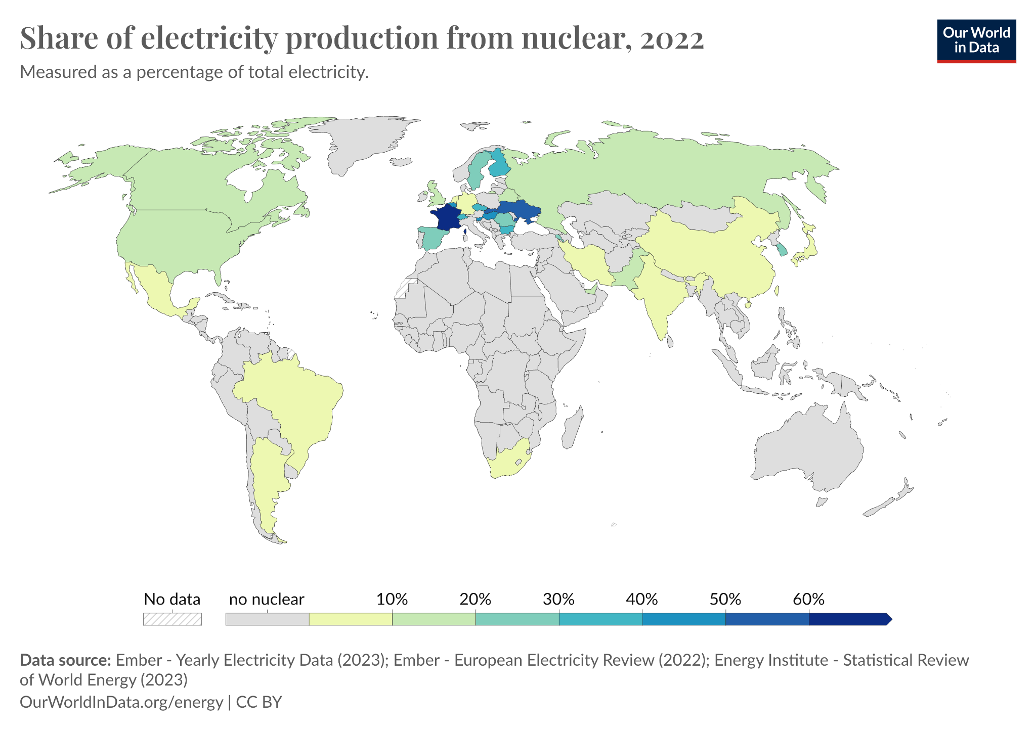

[Fig. 1 Our World in Data, *Share of Electricity Production from Nuclear*, 2022.](https://ourworldindata.org/nuclear-energy)

However, the role of nuclear energy is also subject to challenges and can go hand-in-hand with political tensions. Its role in the global energy mix is shaped by its ability to provide a dependable, low-carbon, and high-density source of power, balanced against economic considerations and societal acceptance (Ritchie and Rosado 2020). As we trickle down towards nuclear energy’s impact on the individual well-being, one can see that it powerfully alleviates energy insecurity, particularly in households that face existing inequalities (World Nuclear Association WNA 2024). Through a systems way of thinking, due to its clean nature, nuclear energy itself can increase air quality–and therefore health–, lower utility bills, take up less space which gives way to more green space, and heavily reduce greenhouse gas (GHG) emissions which inevitably helps drive the world towards carbon neutrality. And yet, its future contribution will likely depend on the governmental support for technological advances, regulatory environments, and global energy policies focused on sustainability and most importantly, the state of the political world in the time that it takes for nuclear innovation and the development cycles to see progress which is usually around a decade.

## **Nuclear Challenges: Overcoming negativity**

While nuclear energy as a whole can be one of the safest and most sustainable energy sources in an ideal world, it is necessary to remember that the current and future state of the world will be involved in multiple political shifts and thus energy shifts as well. Being able to address the sustainability and well-being brought by nuclear energy necessitates a conversation about the stigma of nuclear power. The first one that I find the need to cover is the radioactivity of spent nuclear fuel (SNF) and its longevity which surpasses that of a human life by thousands of years. Nuclear energy can significantly contribute to sustainable development goals if integrated with advanced technological and policy frameworks that address its inherent challenges. Key among these are waste management, operational safety, and public perception.

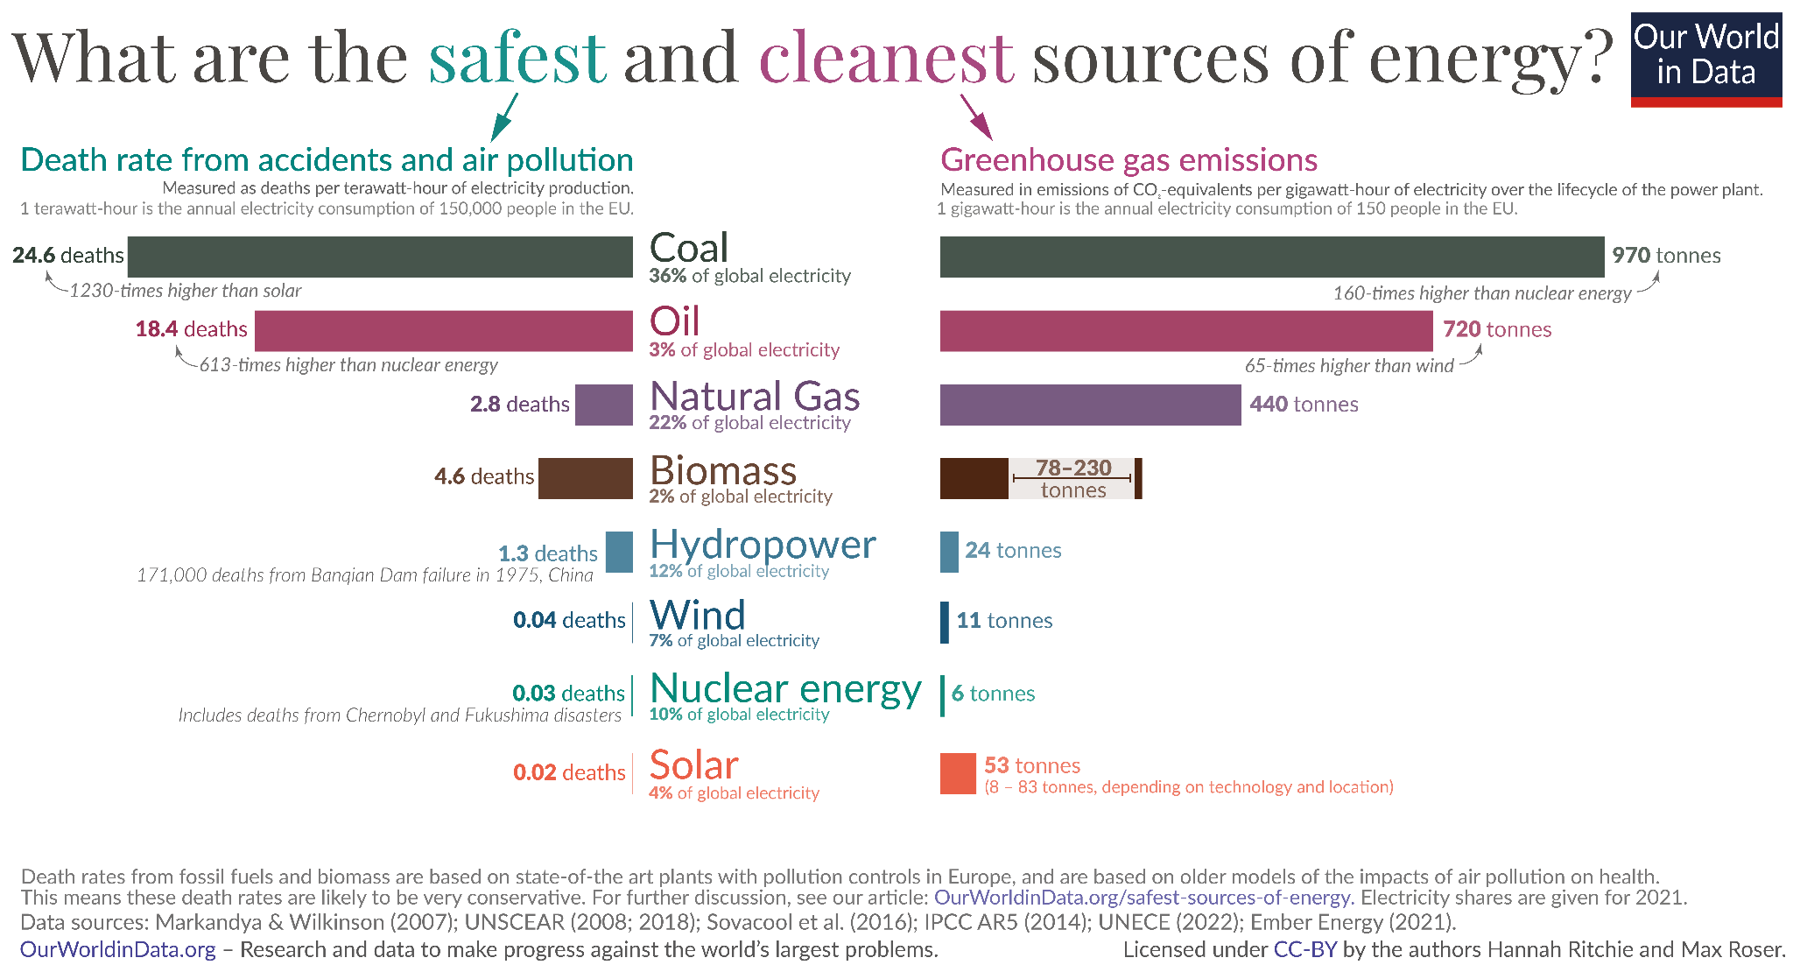

[Fig. 2 Our World in Data, *What are the safest and cleanest sources of energy?*, 2024.](https://world-nuclear.org/information-library/nuclear-fuel-cycle/introduction/nuclear-fuel-cycle-overview.aspx)

As seen above in Figure 2, nuclear energy has one of the lowest death rates associated with it at 0.03 deaths in the EU, and it produces the least amount of greenhouse gases. Correspondingly, the International Energy Agency estimates that nuclear power avoids approximately 2.5 gigatons of carbon dioxide emissions annually, equating to the emissions from about 500 million cars (IEA 2020).

Also, advancements in a closed-cycle generation and nuclear fuel recycling are critical in mitigating the long-term environmental impact of SNF (WNA 2024). Such technologies not only reduce the volume of radioactive waste by reprocessing and reusing the uranium (as noted in figure 3), but also improve the overall thermal efficiency of nuclear reactors and decrease the lifetime in which the waste is harmfully radioactive to around 200 years (WNA 2022).

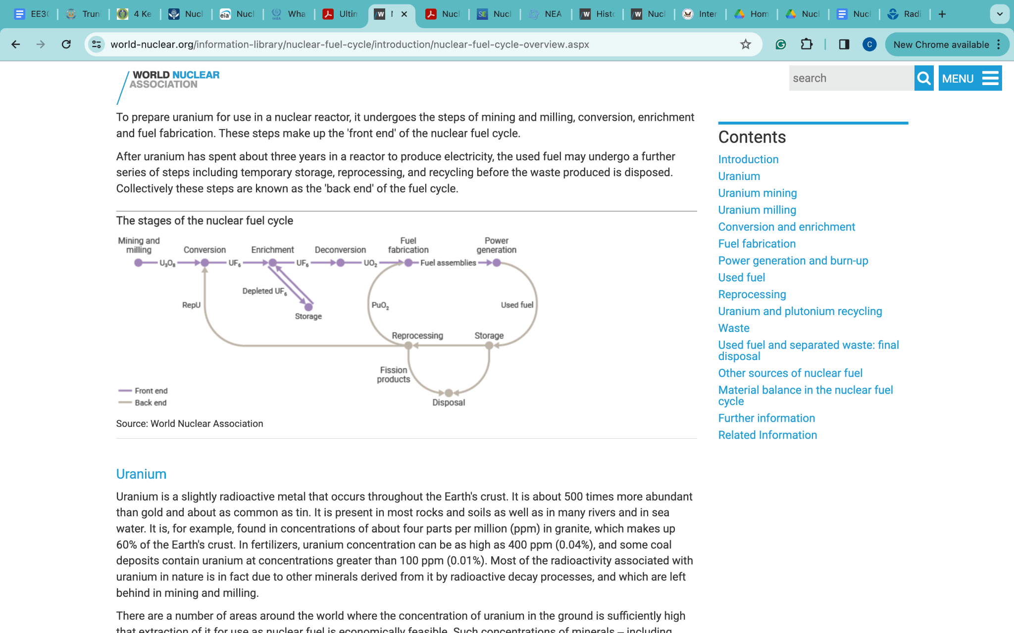

[Fig. 3 World Nuclear Association, *The Stages of the Nuclear Fuel Cycle*, 2024.](https://world-nuclear.org/information-library/nuclear-fuel-cycle/introduction/nuclear-fuel-cycle-overview.aspx)

Addressing the high capital and maintenance costs associated with nuclear energy through the integral adoption of closed cycle systems involves enhancing the material and thermodynamic efficiencies of nuclear reactors, thus aligning economic and environmental sustainability with technological advancement and overall lightening the negativity around the use of nuclear energy.

**Quantitative Impact of Nuclear Energy**

After softening the negative preconceived notions of nuclear power, we can finally approach the quantitative impact this energy service provides in a global sense as a contributor to human well-being. As of recent reports, nuclear energy is responsible for approximately 10% of global electricity production, with 440 nuclear power reactors in operation worldwide as of 2023, generating about 2,600 TWh per year (World Nuclear Association 2023). In monetary terms, the global nuclear power output contributed approximately $500 billion to the world economy in 2023, taking into account the average global electricity rate of 19 cents per kilowatt-hour (International Energy Agency 2023). This economic contribution is further amplified by the sector's employment opportunities, with the nuclear industry supporting over 10 million job-years of employment globally, considering construction, operation, decommissioning, and the entire supply chain (NEA-OECD 2023).

Beyond its economic footprint, the health and environmental benefits of nuclear energy are significant. Nuclear power plants avoid the emission of nearly 2 billion tonnes of CO2 annually, compared to equivalent fossil fuel generation, bolstering climate action efforts and contributing to a decrease in pollution-related health issues (International Atomic Energy Agency 2023).

Moreover, nuclear energy provides a reliable power supply, reducing the risk of energy scarcity and promoting energy security for millions of households. The dependable energy flow from nuclear plants is essential not just for residential stability but also for critical infrastructure such as hospitals and emergency services, which require uninterrupted power to operate effectively.

In the context of human well-being, nuclear medicine, a direct offshoot of nuclear technology, uses radioisotopes for diagnostics and treatment, benefiting approximately 30 million people each year with lifesaving medical procedures like cancer radiotherapy (World Nuclear Association 2023).

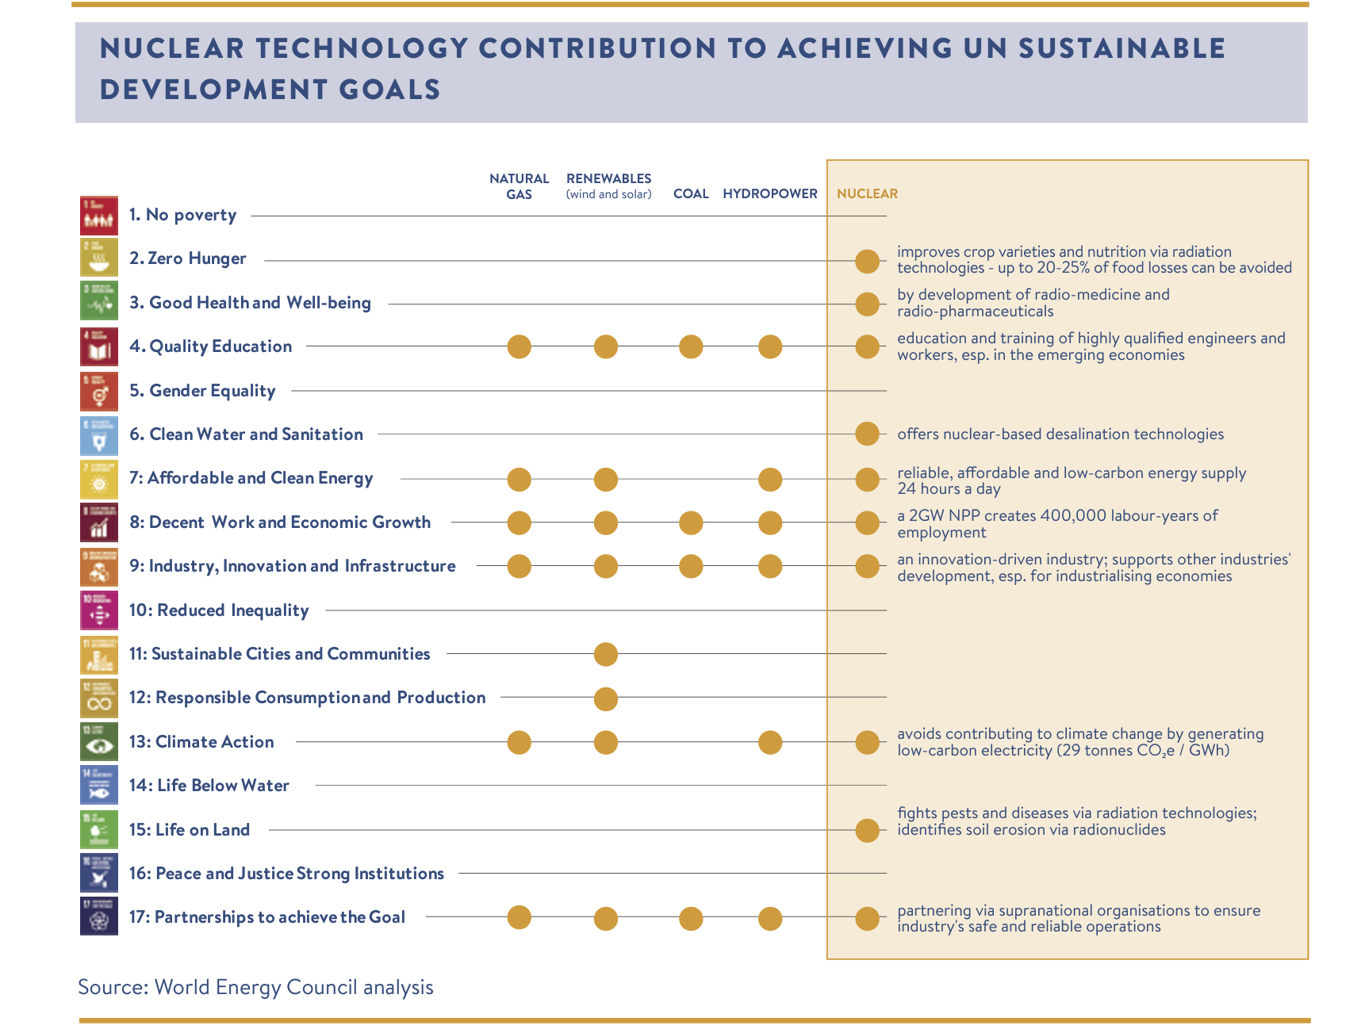

[Fig. 4 World Energy Council, *Nuclear Technology Contribution to Achieving UN Sustainable Development Goals*, 2023.](https://world-nuclear.org/nuclear-essentials/how-can-nuclear-combat-climate-change.aspx)

Thus, the service of nuclear energy extends beyond mere electricity generation, permeating various aspectws of daily life, and delivering benefits in health, economic growth, and environmental sustainability.

**Framework: Energy, Society, and the Environment**

# **Nature**

Nuclear energy begins with the mining of uranium, a **natural resource** that is abundant in the form of isotope U-238. The extraction of this resource can have significant environmental impacts on land and cultural disturbance as seen during the period from the 1940s to the 1980s when the US primarily mined on Navajo land (EPA 2024). The process of mining uranium also affects **living systems** such as the local flora and fauna, which can be displaced or harmed by the alteration of their habitat and it can also lead to the contamination of nearby water sources with heavy metals and radionuclides, all of which impact the biodiversity and health of aquatic ecosystems and populations that live near mines.

Framework links:

* The disruption of the natural landscape and the generation of radioactive waste are part of the ecological challenges that need to be responsibly managed in order to reduce nuclear energy’s footprint on nature as an energy service for electricity (Department of Energy 2021).
* Advancements in technology can mitigate these effects by improving mining techniques that reduce ecological disruption and systems that treat water before it is returned to the environment (NRC 2021).
  + The development of in-situ leaching (ISL) mining techniques has revolutionized uranium extraction. ISL minimizes land disturbance by circulating a leaching solution through uranium-bearing rock strata and pumping the uranium-laden solution to the surface, thereby drastically reducing the ecological disruption traditionally associated with uranium mining (Nancharaiah 2015). Moreover, water treatment systems, such as reverse osmosis and ion exchange, are now implemented to purify water from mining processes before its reintegration into the environment, as highlighted by the Nuclear Regulatory Commission (NRC) in 2021.
* Governments can disperse environmental bonds for private nuclear energy companies to make sure that they return mined land in the same state that it was found, or better (clean water and replanting with native species).
  + A model of this can be seen in Canada, where the Saskatchewan government requires mining companies to obtain a Reclamation Bond before mining. This bond financially ensures that the mining company will rehabilitate the land post-mining, aiming to restore it to an equal or improved ecological state. The reclamation process typically includes decontaminating the water, replanting with native species, and often creating wetlands to enrich local biodiversity, demonstrating a commitment to both environmental stewardship and the well-being of future generations.

# **Direct Drivers of Change (Natural and Anthropogenic)**

Nuclear power plants have a low direct impact on climate change compared to fossil fuels since it does not emit GHGs during electricity generation (NEA 1993). But, the potential for catastrophic events and the long-term challenge of radioactive waste disposal are significant direct impacts that face lots of disputes over whether or not to adopt this energy (Ritchie et al 2020). Although it is a valid worry, we must remember the existing science and knowledge that have weakened this particular argument against nuclear energy. The US’s primary choice in nuclear reactors–lightwater nuclear reactors–, go through a “once-through” nuclear generation process that produces the radioactive waste that the world is worried about. But, if these powerplants were adapted into a “closed-cycle” plant which recycle used fuel or repurpose it for other types of reactors as seen in Figure 5, then we can significantly mitigate the safety concerns and ultimately shift the balance of the debate (Center for Sustainable Systems 2023).

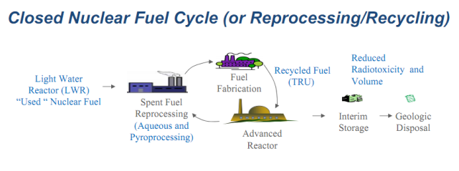

[Fig. 5 New Nuclear Power in the U.S., *Closed Nuclear Fuel Cycle*, 2023.](https://world-nuclear.org/information-library/nuclear-fuel-cycle/introduction/nuclear-fuel-cycle-overview.aspx)

Framework links:

# The anthropogenic environmental consequences of nuclear energy production can affect the natural and living systems which can then affect the benefits that society gets from nature. But, equally, in comparison to that of fossil fuels, nuclear energy produces a more positive impact to the well-being of humans via technological advances and institutional policies that can enable the safe use and distribution of this clean energy service. These technological improvements must be viewed within the broader spectrum of environmental and social systems. The mitigation of anthropogenic impacts, such as waste reduction through "closed-cycle" operations, not only preserves natural ecosystems but also underpins the well-being of societies reliant on these ecosystems. Furthermore, juxtaposed with fossil fuels, nuclear energy offers augmented benefits: it reduces the carbon footprint, thereby contributing positively to human health and the environment, and it demonstrates a commitment to sustainable development through technological innovation and effective policy-making.

# **Indirect Drivers of Change:**

Policy, international agreements, and regulatory frameworks arguably play the most important part as indirect drivers of change when it comes to adopting nuclear energy as a sustainable alternative. These drivers come together to influence the development, operation, and expansion of nuclear facilities by setting the standards for safety, investment, and public engagment. Organizations such as the IAEA, the Nuclear Energy Agency (NEA) within the OECD, the World Nuclear Association (WNA), and the U.S. Nuclear Regulatory Commission (NRC) are crucial decision-makers when it comes to this regulatory landscape (World Energy Council 2019). These institutions and governmental bodies can ensure the safe and sustainable operation of nuclear facilities through international safety standards, cooperation among countries, and strict regulatory practices (NRC 2021).

Public opinion, influenced by media, education, and cultural perceptions all contribute to the oversight of nuclear policy and its popularity as a source of clean power. Historical incidents such as the Chernobyl and Fukushima disasters have shown the world the ugly, weaponized, and irresponsible, side of nuclear energy from a political landscape that was left uncontrolled and unregulated. All of this leads to the wariness in adopting nuclear energy in future sustainable energy strategies. In response, regulatory frameworks become rigid due to public demand for higher safety and transparency. This dynamic shows how the public sentiment is an indirect driver that can create changes in policy which then affect the nuclear sector in any scale.

Framework links:

* Nuclear energy has faced a global energy decline due to the interaction between these indirect drivers of change and human-well being. Such a big part of this is public opinion and governmental operations that limit the way nuclear power is adjusted for positive usage (NEA 1993).
  + A survey conducted in 2023 revealed that public opposition has delayed the construction of new nuclear plants, extending project timelines by an average of four years and increasing costs by up to 45% (International Energy Agency, 2023). Such policies, cultural attitudes, and technology influence how this power is produced and managed which then leads to changes in the direct drivers of environmental change.
* To restate the importance of this dimension of the sustainability framework, the first step in clearing up the path for nuclear energy as a sustainable source is by restructuring indirect drivers themselves and integrating the benefits of nuclear energy into the thought systems that build the foundation of indirect drivers.
* The development of safer and more efficient nuclear technologies is often a response to regulatory and societal pressures.

**Anthropogenic Assets (infrastructure, material goods, financial assets, knowledge):**

Nuclear power plants are part of the built infrastructure and they showcase the grand technological and financial assets that we have been able to generate. The knowledge to build and operate these power plants in a safe and sustainable way is a key technological asset, while financial assets are tied up in the initial investment and ongoing costs of nuclear facilities (World Energy Council 2019).

Framework links:

* A society that values the reliability and cleanliness of nuclear power will then invest more in the technology, infrastructure, and research which then builds the stock of anthropogenic assets.
* As nations build and maintain nuclear infrastructure, there are direct environmental impacts from construction, waste management, and potential accidents, which have to be mitigated via careful planning and technology (WNA 2024).
  + A brief case study is the Finnish nuclear waste management company Posiva, which embarked on a pioneering project to safely store spent nuclear fuel. The Onkalo spent nuclear fuel repository, intended to isolate radioactive waste for up to 100,000 years, represents a significant advancement in waste management technology and a model for environmental responsibility in the nuclear sector (Posiva 2024).

**Human Well-being**

Nuclear energy provides substantial energy services, particularly in terms of electricity for mobility, heating, and cooling, contributing to the material services that support the physical infrastructure of society (Center for Sustainable Systems 2023). It plays a vital role in reducing carbon emissions and enhancing energy security (Ritchie et al 2020). The stable supply of electricity from nuclear power contributes to the provisioning and regulating services of ecosystems, enabling societies to function and develop without the high emissions associated with fossil fuels.

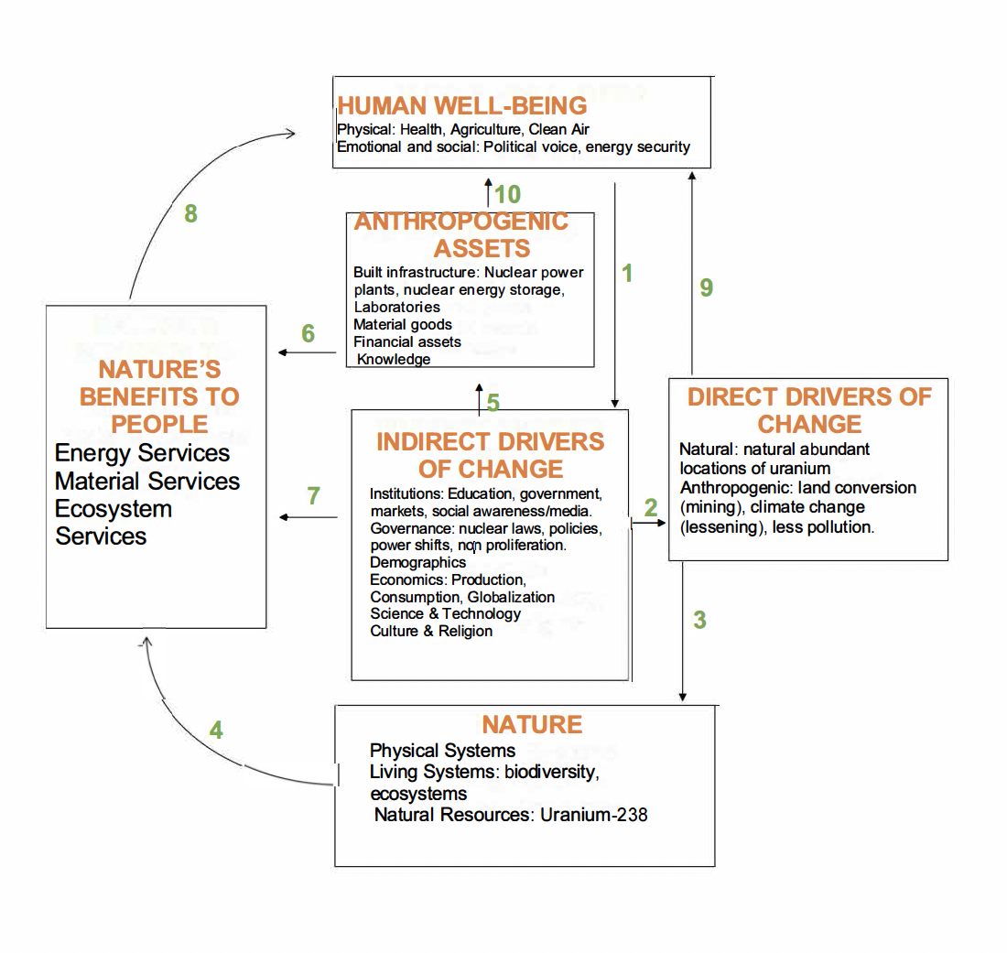

[Fig. 6 Framework for Sustainability, *Nuclear energy as a service*, 2024.](https://world-nuclear.org/information-library/nuclear-fuel-cycle/introduction/nuclear-fuel-cycle-overview.aspx)

# **Linking the Framework**

The economics of nuclear energy can affect demographic shifts if energy costs lead to industrial migration. The inner workings of institutions and governance can also affect how well the benefits of nuclear energy are realized and how effectively its risks are managed. We can see this connection through the framework in Figure 6 of how nuclear energy is governed and its use as a long term sustainable alternative. To deepen our understanding of nuclear energy's role within a sustainability framework, it's crucial to connect the specific components of this framework more explicitly with nuclear energy's direct and indirect impacts. Direct drivers such as technological advancements in nuclear reactor safety have directly mitigated environmental risks, exemplified by the shift towards closed-cycle fuel systems which significantly reduce radioactive waste. Meanwhile, indirect drivers such as regulatory changes post-Fukushima have shaped the development of these technologies, highlighting the dynamic interplay between public policy, technological innovation, and industry practices. This interconnection shows that enhancements in technology and stringent safety standards not only improve public perception but also directly contribute to ecological health and human well-being by providing a more reliable and safer energy source.

Starting with Nature (4), the impacts of mining and the use of uranium impact biodiversity and ecosystems. These impacts on natural resources can be thought of as Direct Drivers (3) that lead to potential environmental degradation. The role of nuclear energy as part of Anthropogenic Assets (10) is important because of how it contributes to the built infrastructure in the form of power plants, energy storage units, and the knowledge base required for its operation. The reliance on these technological assets then lead to Nature’s Benefits to People (6) by providing energy services that are essential for society such as electricity for mobility, health, agriculture, heating and cooling and many others.

In terms of Human Well-being (1), the provision of stable and clean energy has many benefits such as improved health due to reduced air pollution, economic growth via provision of energy for industries, and enhanced security from energy independence for all populations.

The Indirect Drivers (5) involve a variety of factors such as laws, policies, economic considerations, and technological advancements. Nuclear energy policy is directly influenced by these drivers which contribute to how nuclear technology is developed, implemented, and regulated. This can include international policies aiming at non-proliferation, national laws ensuring environmental and public safety, and economic strategies that affect the financing and cost-effectiveness of nuclear energy.

# **Existing Measures and Future Directions**

Currently, there are many measures in place to ensure the sustainable use of nuclear energy, including policies, technological advancements, business practices, and community involvement. The International Atomic Energy Agency (IAEA) sets guidelines and standards that influence national policies on nuclear safety and security. In the US, the Nuclear Regulatory Commission (NRC) oversees nuclear reactor safety, integrating research from facilities like the Argonne National Laboratory, which focuses on improving nuclear reactor efficiency and safety, security, and environmental compliance in a strictly regulated manner.

In a technological sense, the development of small modular reactors (SMRs) and Generation IV reactors act in accordance with a precautionary principle when it comes to handling radioactive waste and its severity. SMRs are becoming the face of nuclear energy as they lower the costs of manufacturing and offer safety features, efficiency, and reduced radioactive waste. Countries like Russia and China are at the forefront of adopting and developing these technologies both onshore and offshore, while the technology for recycling spent nuclear fuel (SNF) so that there is reduced waste and overall uranium costs is being refined in France and Japan.

On the business side, top nuclear energy companies like Westinghouse Electric Company and Rosatom are beginning to adopt sustainable practices such as lifecycle management of nuclear plants and adherence to international environmental management standards like ISO 14001 (Rosatom, Westinghouse 2024). There is also increasing investment in research and development in order to improve the efficiency and sustainability of nuclear technologies such as those involved in the Advanced Modular Reactor (AMR) projects.

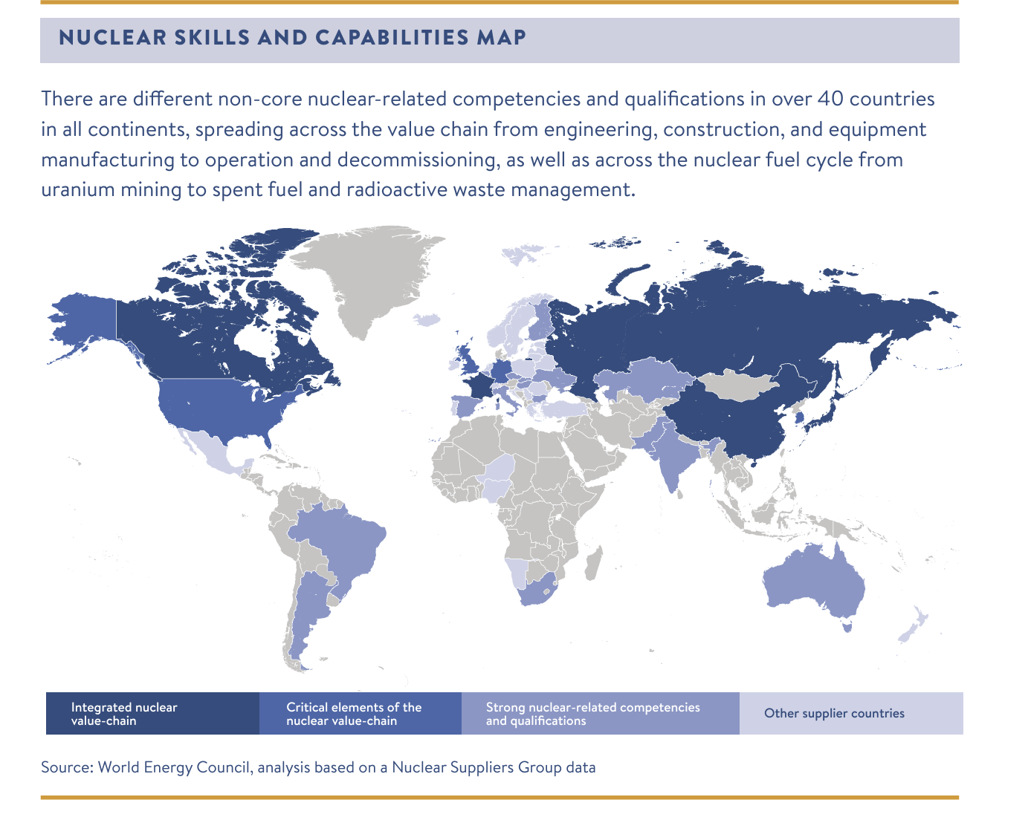

[Fig. 7 World Energy Council, Nuclear Skills and Capabilities Map, 2024.](https://world-nuclear.org/information-library/nuclear-fuel-cycle/introduction/nuclear-fuel-cycle-overview.aspx)

Lastly, the current community actions like those in Finland where the planning and operation of new nuclear facilities involve in-depth public consultation to address community concerns. There are also NGOs and community groups like Greenpeace and the Nuclear Information and Resource Service (NIRS) that lead educational conversations which raise awareness of the benefits and risks associated with nuclear power.

As a way to strengthen the sustainable use of nuclear energy, there are several measures we must put to action. The first being that of better international cooperation which can improve the global governance on nuclear safety as a whole from the mining of uranium to the reprocessing of SNF. This will help ensure that there is a high standard for safety and effective emergency responses, and allow for the renewal of nuclear energy in the global energy mix in the coming future.

The second part of reviving and strengthening nuclear energy for more global usage is by increasing transparency and engaging the public, particularly stakeholders. These measures begin paving the way in promoting nuclear energy as a key part of national and international strategies for achieving carbon neutrality and therefore contribute to the progress for long-lasting sustainability that can contribute to global energy security and environmental sustainability while responsibly meeting the increasing energy demands.

Policy-wise, an international standard for nuclear waste management should be implemented, enforced by a dedicated body under the United Nations to ensure global adherence to best practices in safety and waste disposal. Technologically, governments should prioritize funding for the development of Generation IV nuclear reactors, which offer superior safety and efficiency. These initiatives should be supported by transparent communication practices, ensuring communities near nuclear facilities are well-informed and actively engaged. For instance, adopting the Finnish model of community consent for nuclear projects could significantly enhance local support and engagement, fostering a collaborative approach to nuclear energy development.

**Conclusion**

Nuclear energy presents a significant opportunity for sustainable development, addressing critical challenges such as climate change, energy security, and economic growth. The narrative surrounding nuclear power has been filled with controversies and historical setbacks, yet the substantial benefits it offers—high energy density, low greenhouse gas emissions, and the potential to significantly enhance human well-being in the long-run—highlight its potential as an important part of leading a sustainable energy future. As we move forward, it is imperative that we address the inherent challenges of nuclear energy, such as waste management, safety concerns, and public perception, through advanced technological solutions and robust policy frameworks. Additionally, fostering global cooperation and transparent engagement with stakeholders will be crucial in enhancing the acceptance and integration of nuclear power into the global energy mix. By prioritizing innovation and regulatory excellence, nuclear energy can indeed play a critical role in achieving a sustainable, low-carbon future, offering a reliable and powerful solution to the world's growing energy demands. Thus, embracing nuclear energy with cautious optimism and proactive governance can lead to a more sustainable and prosperous global society.

Works Cited

“Abandoned Mines Cleanup | US EPA.” *Environmental Protection Agency*, 5 March 2024, https://www.epa.gov/navajo-nation-uranium-cleanup/abandoned-mines-cleanup. Accessed 16 April 2024.

“Advantages and Challenges of Nuclear Energy.” *Department of Energy*, 29 March 2021, https://www.energy.gov/ne/articles/advantages-and-challenges-nuclear-energy. Accessed 15 April 2024.

Argonne Laboratory. “Pyroprocess and Waste Form Development.” *Argonne National Laboratory*, https://www.anl.gov/cfc/pyroprocess-and-waste-form-development. Accessed 18 April 2024.

Ashok, S. “Nuclear energy | Definition, Sources, Uses, & Facts.” *Britannica*, 8 March 2024, https://www.britannica.com/science/nuclear-energy. Accessed 15 April 2024.

“Backgrounder On Environmental Monitoring At Nuclear Power Plants | NRC.gov.” *Nuclear Regulatory Commission*, https://www.nrc.gov/reading-rm/doc-collections/fact-sheets/env-monitoring.html. Accessed 16 April 2024.

Benke, Erika. “Finland's plan to bury spent nuclear fuel for 100000 years.” *BBC*, 13 June 2023, https://www.bbc.com/future/article/20230613-onkalo-has-finland-found-the-answer-to-spent-nuclear-fuel-waste-by-burying-it. Accessed 18 April 2024.

Cutler, Cleveland J. *The Sustainability Challenge*. Cambridge University Press, trunity-cdn3.sfo2.digitaloceanspaces.com.

Dowdy, WL. “The Politics of Oil in the Wake of Yom Kippur.” *U.S. Naval Institute*, https://www.usni.org/magazines/proceedings/1974/july/politics-oil-wake-yom-kippur. Accessed 15 April 2024.

“5 Fast Facts About Nuclear Energy.” *Department of Energy*, 23 March 2021, https://www.energy.gov/ne/articles/5-fast-facts-about-nuclear-energy. Accessed 15 April 2024.

Jaganmohan, Madhumitha. “Countries using the most nuclear energy 2022.” *Statista*, 9 January 2024, https://www.statista.com/statistics/201683/percentage-of-world-nuclear-electricity-consumption-by-country/. Accessed 18 April 2024.

Nancharaiah, Francis. “In situ and ex situ bioremediation of radionuclide-contaminated soils at nuclear and norm sites.” Science Direct, 5 March 2024, https://www.sciencedirect.com/topics/engineering/situ-leaching. Accessed 24 April 2024.

“Nuclear.” *Department of Energy*, https://www.energy.gov/nuclear. Accessed 15 April 2024.

“NUCLEAR ENERGY.” *Department of Energy*, https://www.energy.gov/sites/default/files/2019/01/f58/Ultimate%20Fast%20Facts%20Guide-PRINT.pdf. Accessed 15 April 2024.

Nuclear Energy Agency. “Broad impacts of nuclear power.” *Nuclear Energy Agency (NEA)*, https://oecd-nea.org/brief/brief-09.html. Accessed 16 April 2024.

“Nuclear Energy and Sustainable Development - World Nuclear Association.” *World Nuclear Association*, https://world-nuclear.org/information-library/energy-and-the-environment/nuclear-energy-and-sustainable-development.aspx. Accessed 15 April 2024.

“Nuclear Energy Factsheet | Center for Sustainable Systems.” *Center for Sustainable Systems*, https://css.umich.edu/publications/factsheets/energy/nuclear-energy-factsheet. Accessed 16 April 2024.

“Nuclear explained - data and statistics - U.S. Energy Information Administration.” *EIA*, https://www.eia.gov/energyexplained/nuclear/data-and-statistics.php. Accessed 15 April 2024.

“Nuclear explained - U.S. Energy Information Administration.” *EIA*, https://www.eia.gov/energyexplained/nuclear/. Accessed 15 April 2024.

Posiva. “Posiva.” *Posiva - Front page*, https://www.posiva.fi/en/. Accessed 24 April 2024.

Ritchie, Hannah, and Pablo Rosado. “Energy Mix.” *Our World in Data*, https://ourworldindata.org/energy-mix. Accessed 15 April 2024.

Rosatom. “Rosatom State Atomiс Energy Corporation ROSATOM global leader in nuclear technologies nuclear energy.” Rosatom State Atomiс Energy Corporation ROSATOM global leader in nuclear technologies nuclear energy, https://www.rosatom.ru/en/about-us/. Accessed 24 April 2024.

“10 Intriguing Facts About the World's First Nuclear Chain Reaction.” *Department of Energy*, 1 December 2017, https://www.energy.gov/ne/articles/10-intriguing-facts-about-worlds-first-nuclear-chain-reaction. Accessed 15 April 2024.

Westinghouse Electric. “About Us.” Westinghouse Electric Company, https://www.westinghousenuclear.com/about/. Accessed 24 April 2024.

“What is Fusion, and Why Is It So Difficult to Achieve? | IAEA.” *International Atomic Energy Agency*, 10 May 2021, https://www.iaea.org/bulletin/what-is-fusion-and-why-is-it-so-difficult-to-achieve. Accessed 15 April 2024.

“World Energy Scenarios 2019.” *World Energy Council*, 9 September 2019, https://www.worldenergy.org/assets/downloads/Nuclear_Scenarios_Report_FINAL.pdf. Accessed 18 April 2024.

World Nuclear Association. “China Nuclear Power | Chinese Nuclear Energy.” *World Nuclear Association*, https://world-nuclear.org/information-library/country-profiles/countries-a-f/china-nuclear-power.aspx. Accessed 18 April 2024.

World Nuclear News. “IAEA releases guide to stakeholder engagement : Corporate.” *World Nuclear News*, 6 January 2022, https://world-nuclear-news.org/Articles/IAEA-releases-guide-to-stakeholder-engagement. Accessed 18 April 2024.

# 